Functional Requirements:

1. The system shall allow a customer to withdraw money from his/her banking accounts.
   1. The system shall display a user menu to the customer.

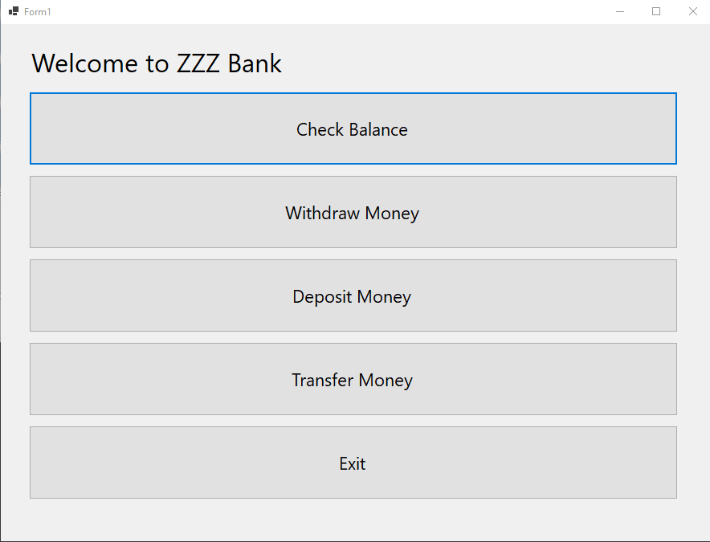

Figure 1 Main Menu Display

* 1. The customer shall select “Withdraw Money” in the menu.
  2. The system shall display a list of accounts of the customer to be selected for withdrawal.

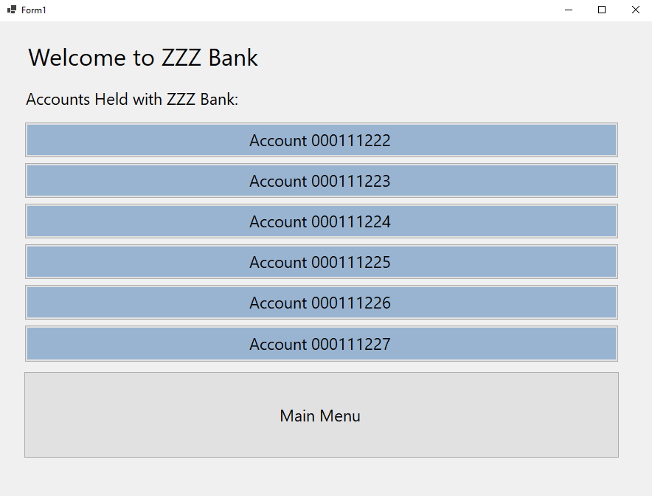

Figure 2 Withdraw Account List

* + 1. The system shall retrieve the account information from the central database system with the customer’s id.
    2. The system shall format and display only account numbers to the customer.
  1. The customer shall select one account from the list for withdrawal.
  2. The system shall update the date of the daily transactions of the selected account.
     1. If the last date of the transactions is not today’s date, the system shall change the date of the transactions to today’s date and reset the daily transaction total to $0.
  3. The system shall check if the account’s daily transaction total has reached $3000 (see NR1).
     1. If the total has reached $3000 already, the system shall display an error message to the customer, and check if there is any other account to be selected for withdrawal.

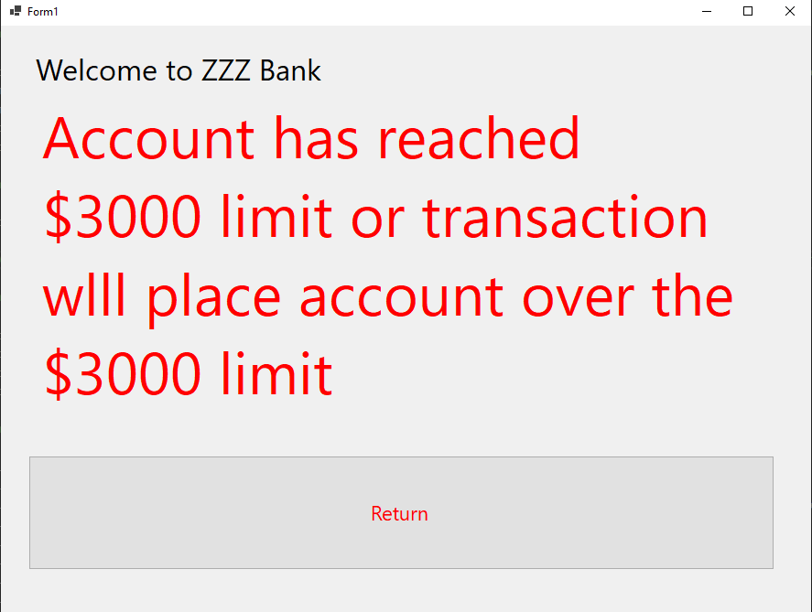

Figure 3 Daily Limit Error Message

* + - 1. If there are more accounts to be selected, return Step 1.3.
      2. If there is not any other account to be selected, return to Step 1.1.
    1. If they haven’t reached $3000, the system shall continue Step 1.6.
  1. The system shall request the customer to enter the amount to withdrawal.

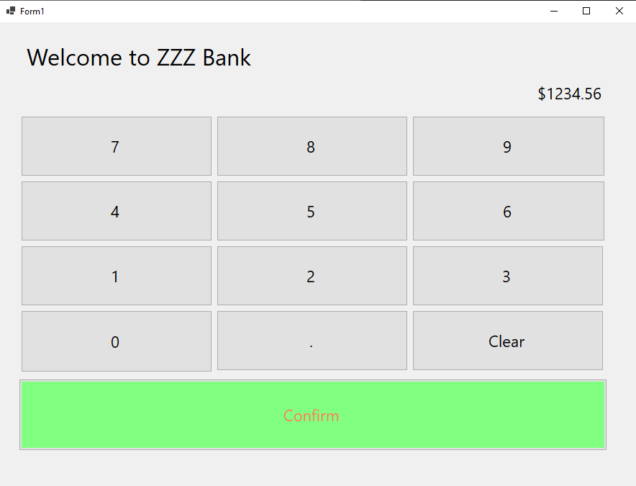

Figure 4 Account Withdraw Form

* 1. The customer shall enter an amount.
  2. The system shall check if the total of the amount plus the daily transaction total is greater than $3000 (see NR1).
     1. If the total is greater than $3000, the system shall display an error message to the customer, and return to Step 1.5.



Figure 5 Daily Limit Error Message

* + 1. If the total is less than or equal to $3000, the system shall continue Step 1.9.
  1. The system shall verify if the amount is less than the current balance of the selected account.
     1. If the amount is greater than the balance, the system shall display an error message to the customer, and return to Step 1.5.

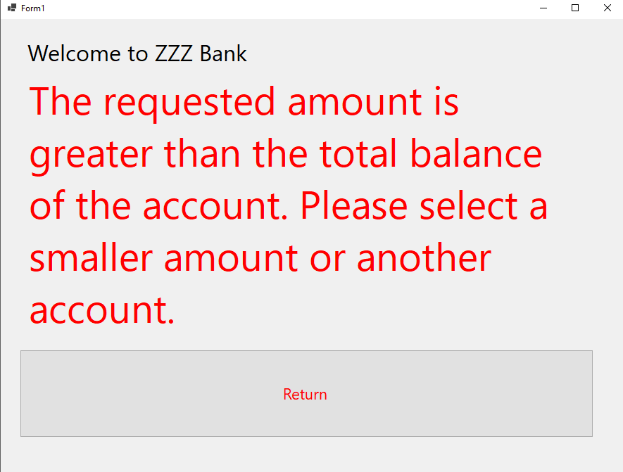

Figure 6 Account Balance Error

* + 1. If the amount is less than or equal to the current balance, the system shall continue Step 1.10.
  1. The system shall check if the machine has enough cash for the withdrawal.
     1. If there is not enough cash for the withdrawal, the system shall display an error message, and return to Step 1.6.

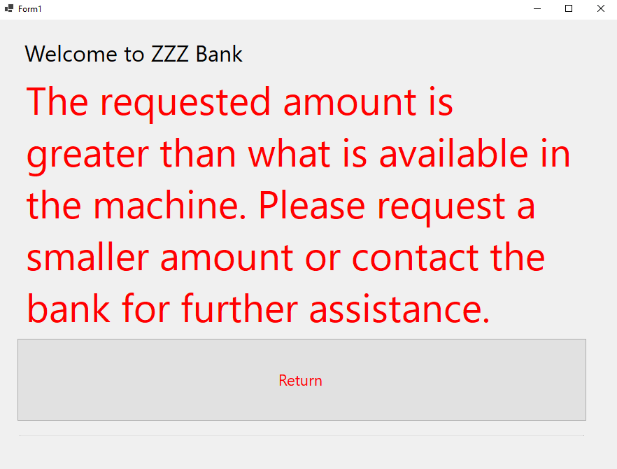

Figure 7 Machine Limit Error

* + 1. If there is enough cash for the withdrawal, the system shall continue Step 1.11.
  1. The system shall dispense the cash.
  2. The system shall deduct the amount from the balance of the account.
  3. The system shall add the amount to the daily transaction total.
  4. The system shall store this transaction to the database.
  5. The system shall update the account information in the database.
  6. The system shall return to main menu.

1. The system shall allow a customer to deposit money to his/her banking accounts.
   1. The system shall display a user menu to the customer.

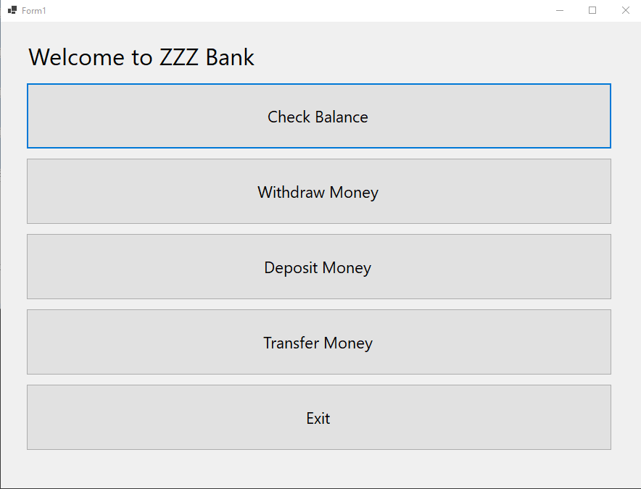

Figure 8 Main Menu

* 1. The customer shall select “Deposit Money” in the menu.
  2. The system shall display a list of accounts of the customer to be selected for deposit.
     1. The system shall retrieve the account information from the central database system with the customer’s id.
     2. The system shall format and display only account numbers to the customer.

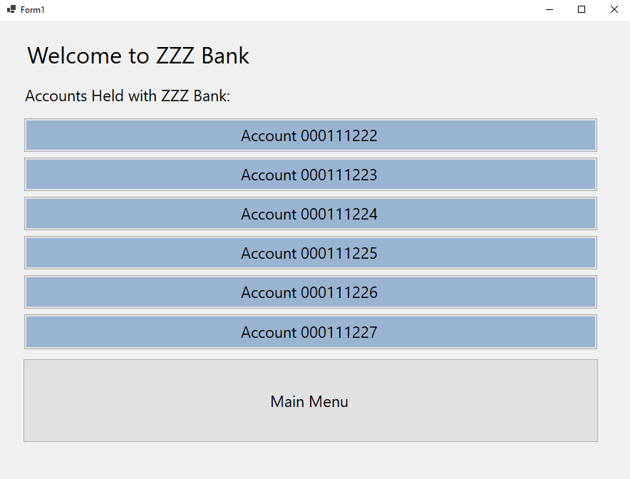

Figure 9 Account List

* 1. The customer shall select one account from the list for deposit.
  2. The system shall display choices for both “Cash” and “Check” deposits

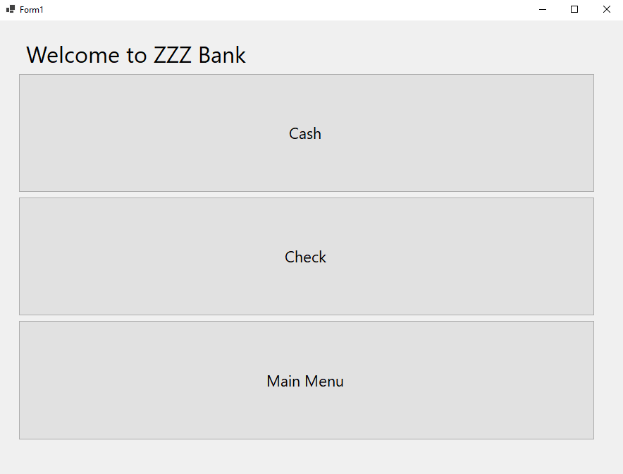

Figure 10 Cash or Check Menu Screen

* 1. The customer shall select the appropriate choice of either “Cash” or “Check”
     1. If the customer has selected “Cash” the system shall display a prompt to insert the desired deposit into the designated slot.

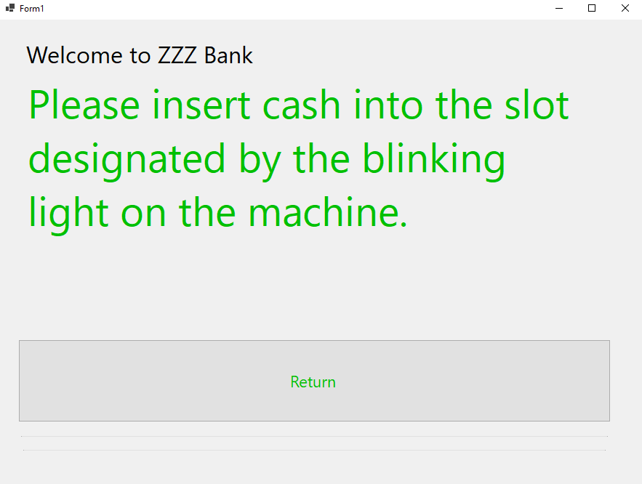

Figure 11 Cash Deposit Prompt

* + - 1. If the customer has successfully inserted cash following the prompt, the system shall display the total amount that has been inserted this session.
      2. The system shall then prompt the customer to verify that the amount is correct and there are no additional deposits or if they would like to make an additional deposit

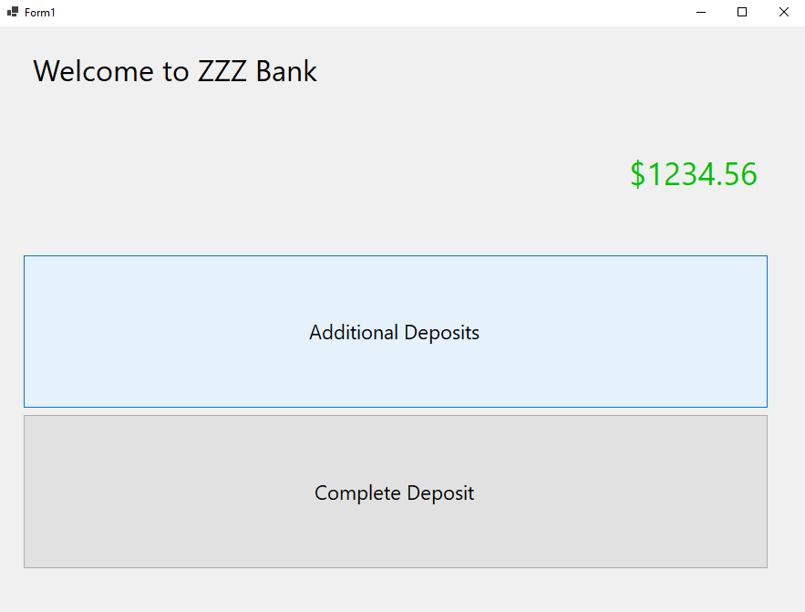

Figure 12 Cash Deposit Confirmation

* + - * 1. If the customer verifies they have no additional deposits the system shall continue to Step 2.7
        2. If the customer selects an additional deposit, the system shall return to Step 2.5.
    1. If the customer has selected “Check” the system will display a prompt for the amount on the check(s).



Figure 13 Check(s) Amount Entry Form

* + 1. The system shall display a prompt for the customer to insert the check into the designated slot upon receiving the input amount.

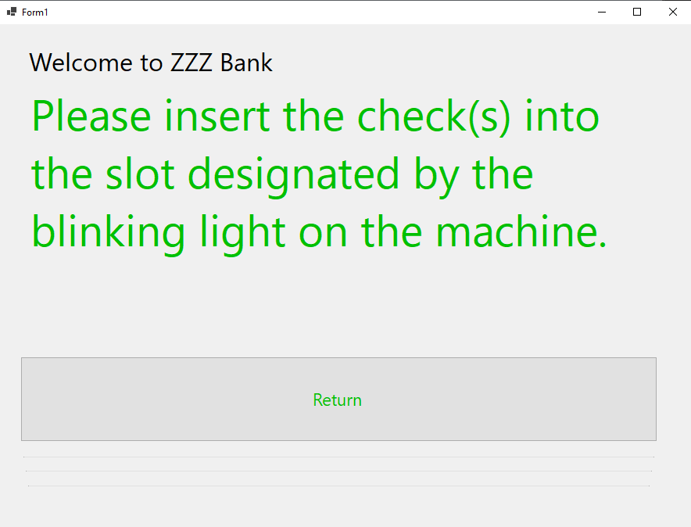

Figure 14 Check(s) Insertion Prompt

* + 1. The customer shall insert the check(s) into the designated slot.
       1. The system shall then prompt the customer to verify if that was their only deposit or if they had additional amounts to deposit.

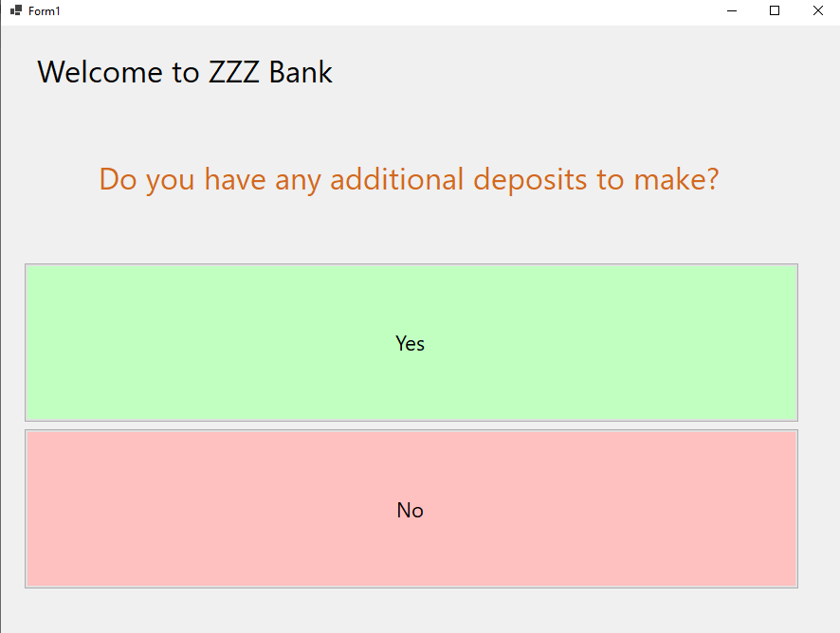

Figure 15 Additional Deposit Confirmation

* + - * 1. If the customer verifies that they have no additional deposits the system shall continue to Step 2.7.
        2. If the customer selects an additional deposit, the system shall return to Step 2.5.
  1. The system shall display the total amount of all deposits from this customer session to the customer and prompt for finalization of deposit.

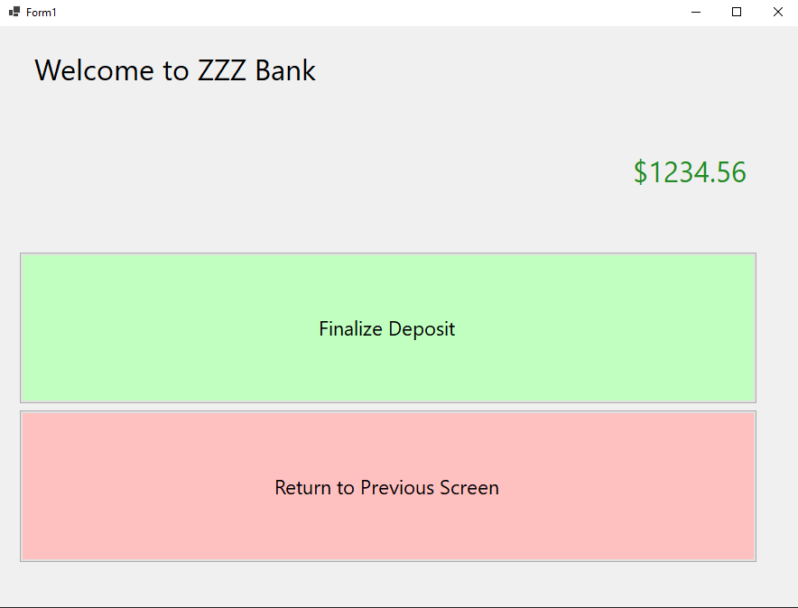

Figure 16 Deposit Finalization

* 1. The customer shall select Finalize.
  2. The system shall store the deposited amount as a pending deposit in the database. (This amount will show as pending until handled by a bank employee. See NR3)
  3. The system shall update the account information.
  4. The system shall return to the main menu.

1. The system shall allow a customer to transfer money between his/her banking accounts.
   1. The system shall display a user menu to the customer.



Figure 17 Main Menu

* 1. The customer shall select “Transfer Money” from the menu options.
  2. The system shall display a list of accounts of the customer to be selected for the funds to be transferred **From**.
     1. The system shall check that there is a minimum of two accounts returned from the central database system.
        1. If there are less than two accounts, there cannot be a transfer. The system shall display an error message to the user explaining this.

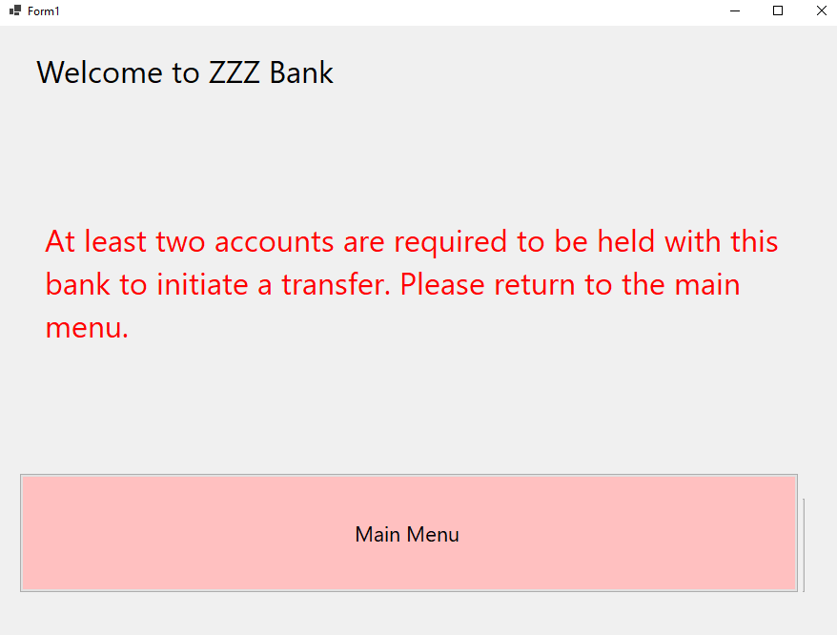

Figure 18 Minimum 2 Accounts Error Message

* + - 1. The system shall return to the main menu.
    1. The system shall format and display only account numbers to the customer.



Figure 19 Accounts List

* 1. The customer shall select one of the accounts selected to be the account money is transferred from. (See NR4)
  2. The system shall display a new list of all other accounts previously returned, excluding the one just selected by the customer. This account will **Receive** the funds.

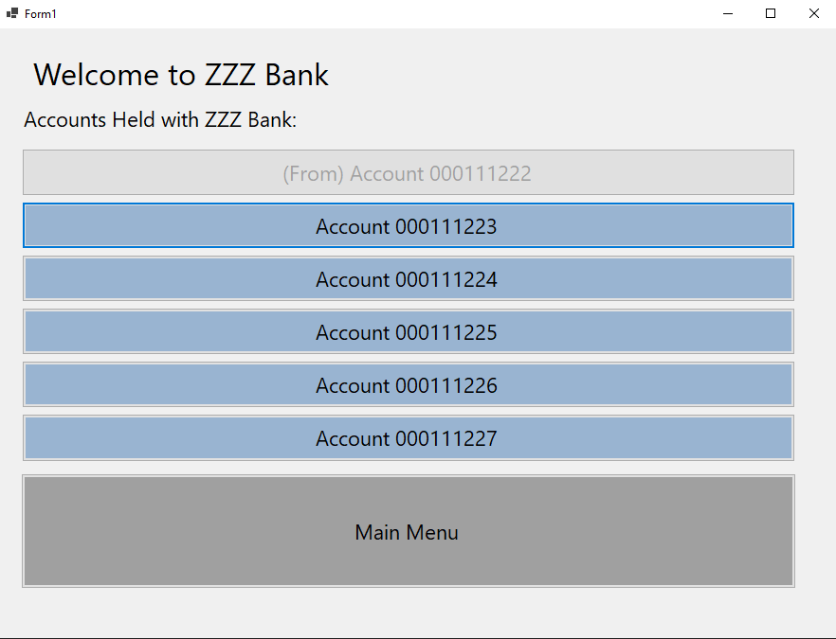

Figure 20 Second Account Selection List

* 1. The customer shall select one of the accounts selected to be the account money is transferred towards.
  2. The system shall display the two accounts, with the From account on the left, and the Receive account on the right.

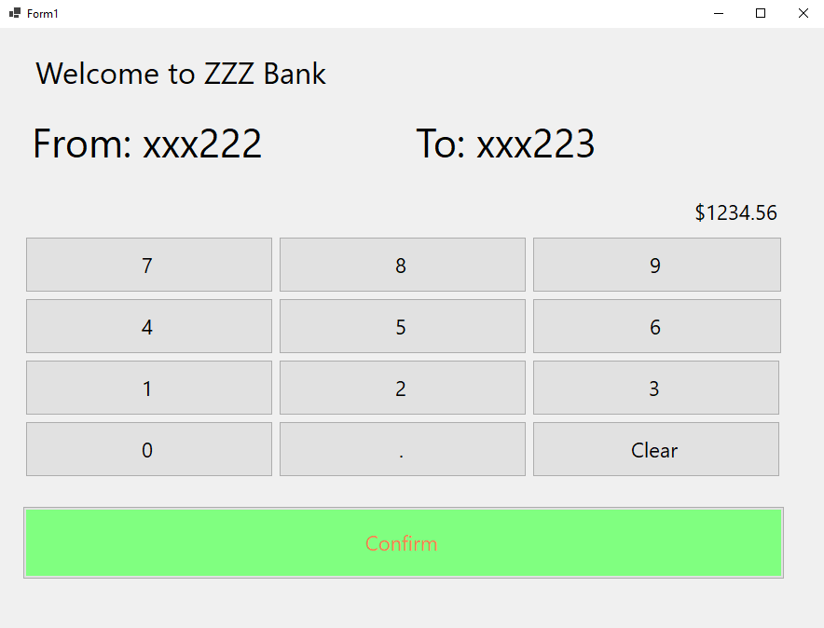

Figure 21 Transfer Input Screen

* 1. The system shall prompt the customer to input the transfer amount.
  2. The customer shall input the transfer amount.
  3. The system shall check that the transfer amount is not greater than the balance of the From account.
     1. If the transfer amount is greater, the system shall display an error message and prompt the customer for the option to either return to the “Transfer Amount” screen or return to the main menu.

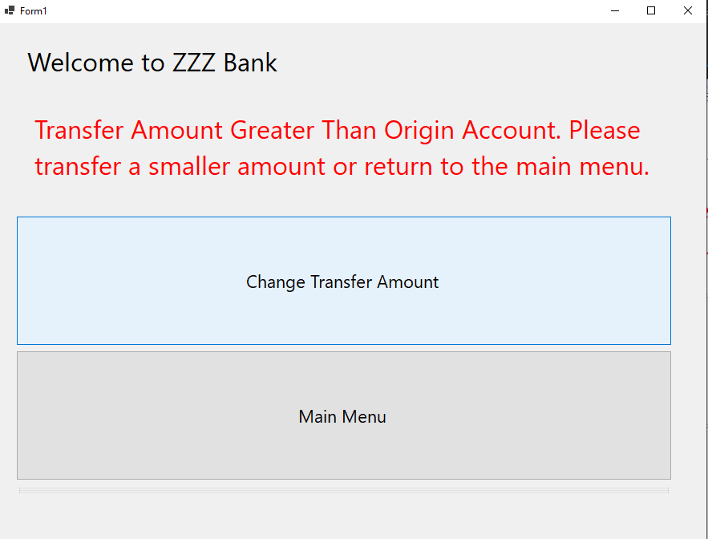

Figure 22 Transfer Greater Than Balance Error Screen

* + - 1. If the customer selects “Transfer Amount”, the system shall return to Step 3.8
      2. If the customer selects main menu, the system shall return to the main menu
  1. The System shall check that the current daily transaction amount for each account plus the transfer amount is below $3000 (See NR1).
     1. If the transfer amount places either account above the $3000 limit, the system shall display an error to the user and return to the main menu.

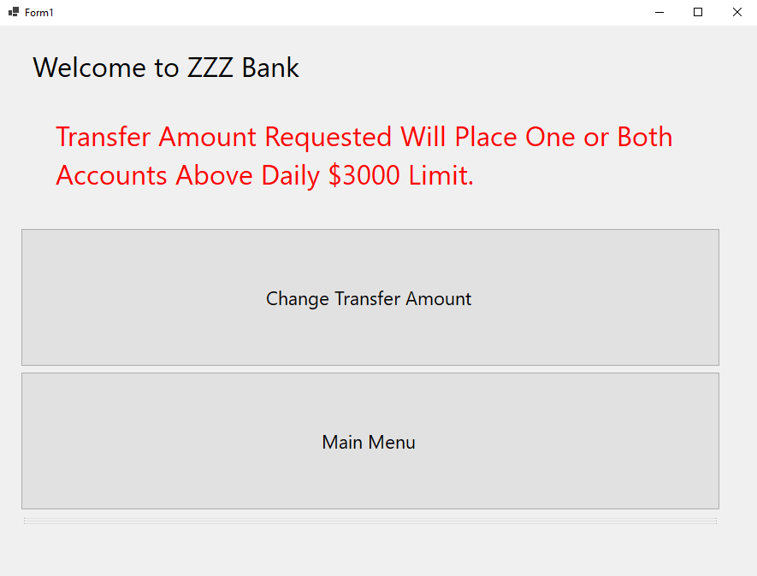

Figure 23 Transfer Daily Limit Error Screen

* 1. The system shall prompt the customer to verify that the transfer amount is correct and if they would like to finalize the transfer.

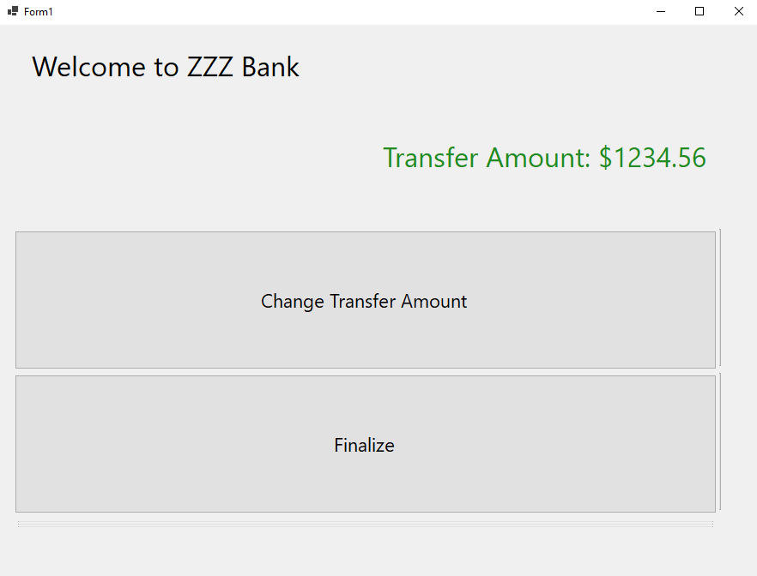

Figure 24 Transfer Finalize Screen

* 1. The customer shall select finalize.
  2. The system shall update the date of the daily transaction to reflect the date/time of the transfer.
  3. The system shall update the balances of both accounts.
  4. The system shall add the amount to the daily transaction total.
  5. The system shall store the transaction in the database.
  6. The system shall update the account information in the database.
  7. The system shall return to the main menu.

1. The system shall allow a customer to check the balance of their account.
   1. The system shall display a user menu to the customer.



Figure 25 Main Menu

* 1. The user shall select “Check Balance” from the menu options
  2. The system shall display a list of accounts of the customer to be selected for deposit.
     1. The system shall retrieve the account information from the central database system with the customer’s id.
     2. The system shall format and display only account numbers to the customer.



Figure 26 Account List Formatted in ID’s Only

* 1. The user shall select an account from the list provided by the system.
  2. The system shall display the balance of the selected account.

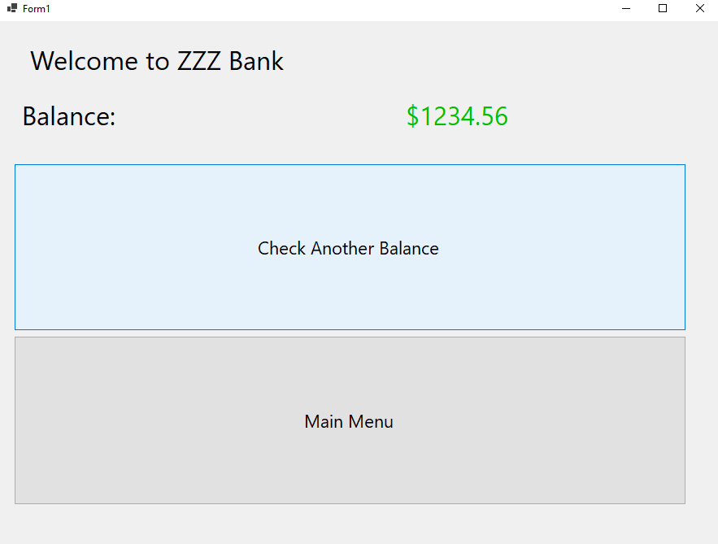

Figure 27 Account Balance and User Prompt Screen

* 1. The system shall prompt the user to whether they would like to check the balance of another account or return to the main menu.
     1. If the customer chooses to check the balance of another account, the system shall return to Step 4.3
     2. If the customer chooses to return to the main menu, the system shall continue to Step 4.7
  2. The system shall store the balance check transaction in the database.
  3. The system shall return to the main menu.

1. The system shall validate customer login through their bank card before allowing access to the user menu.
   1. The system shall prompt the customer to insert their card at all times that there is not an active customer at the machine.

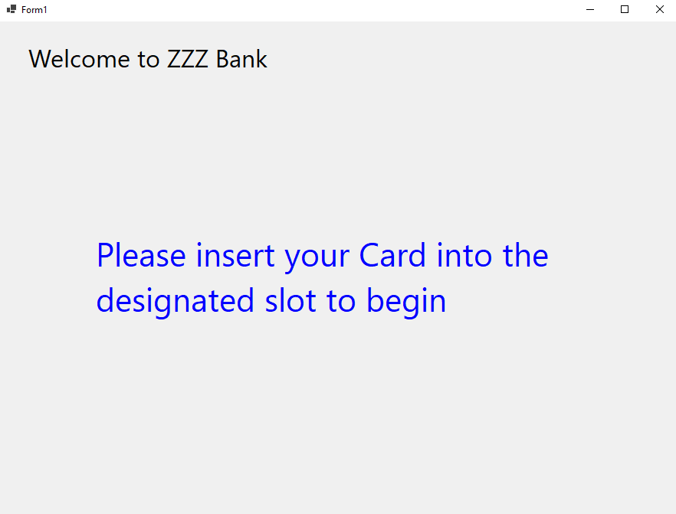

Figure 28 Card Insertion Prompt

* 1. The customer shall insert their card into the designated slot into the machine.
  2. The system shall prompt the customer to enter their account pin number to validate their identity.

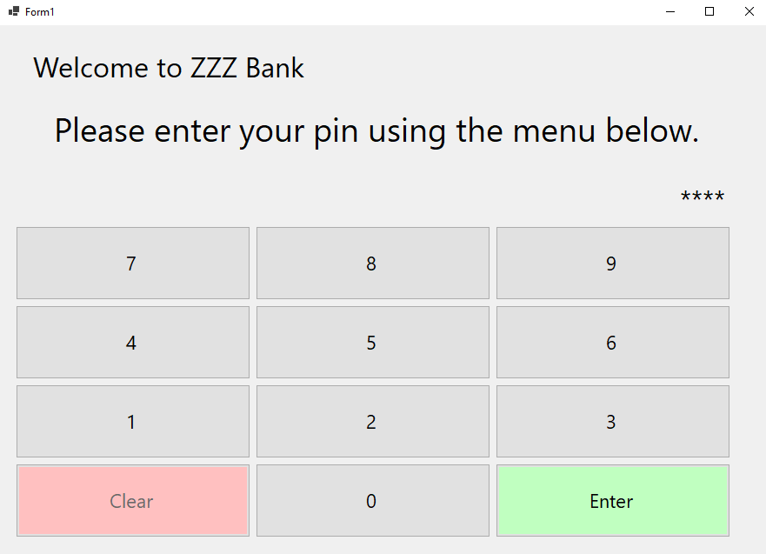

Figure 29 PIN Login Screen

* 1. The customer shall enter their pin.
  2. The system shall validate the pin against the card with the bank’s authorization service.
     1. If the pin is not correct, the system shall display an error message and increment the number of failures by one.

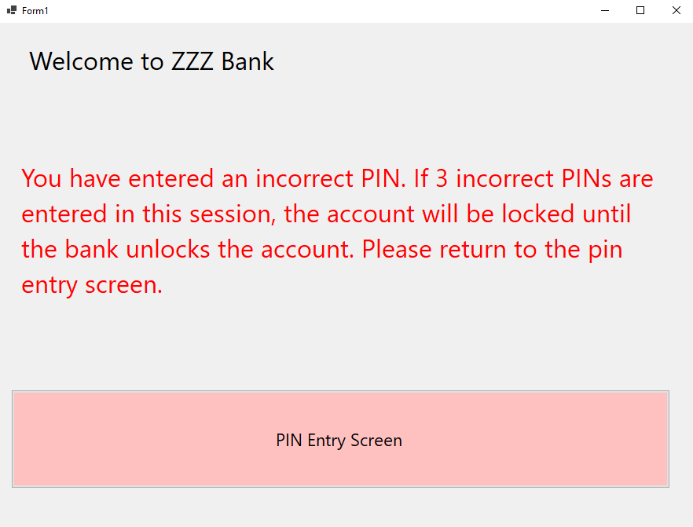

Figure 30 Incorrect PIN Error Screen

* + - 1. If the number of failures is less than 3, the system will return to Step 5.4.
      2. If the number of failures is greater than or equal to 3, the account will be locked and require a bank employee to reenable ATM transactions.
  1. The system shall display the user menu described in R6.

1. The system shall provide a user menu for withdraws, deposits, balance checks, transfers, and log off functionality.
   1. The system shall display a menu with user input options to withdraw, deposit, check balances, transfer between accounts, or exit.



Figure 31 Main Menu Screen

* 1. The customer shall select one of those options.
     1. If the customer selects Withdraw, the system shall follow R1.
     2. If the customer selects Deposit, the system shall follow R2.
     3. If the customer selects Transfer, the system shall follow R3.
     4. If the customer selects Balance Check, the system shall follow R4.
     5. If the customer selects Exit the system shall proceed to Step 6.3.
  2. The system shall end the current user session.

Non-functional Requirements:

1. The total of daily transactions (withdrawals ad money transfers) shall not exceed $3000 from same account.
2. The cash in a machine will be reset to $100000 every day. This action will be done manually by the employees of the bank (The software system is not responsible for this part.)
3. The amount of a deposit will not be added to the balance of an account immediately. The system will show the deposit amount in another way. The action for adding the amount to the balance will be done manually by the employees of the bank (The software system is not responsible for this part.)

**Domain Diagram:**

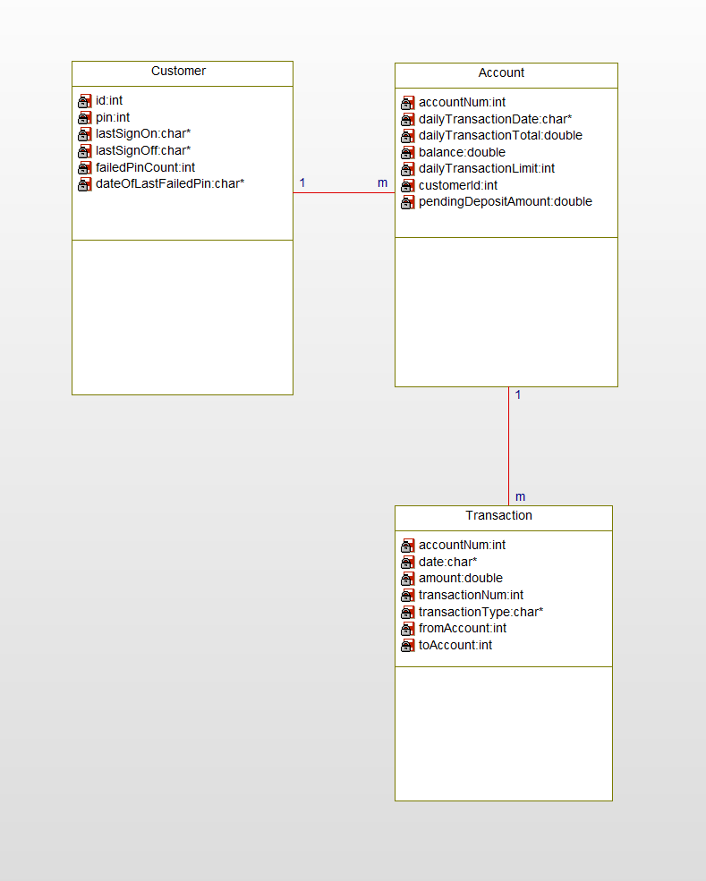

**Use Case Diagram:**

